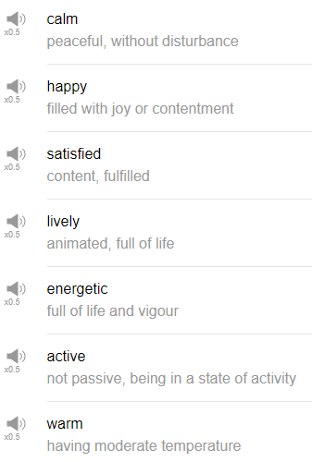

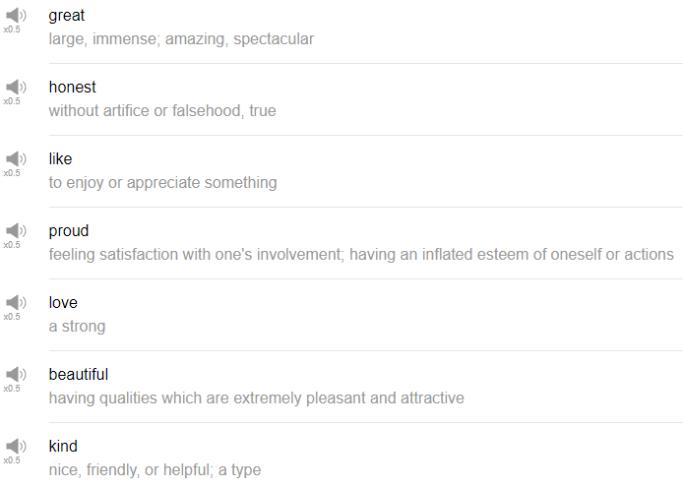

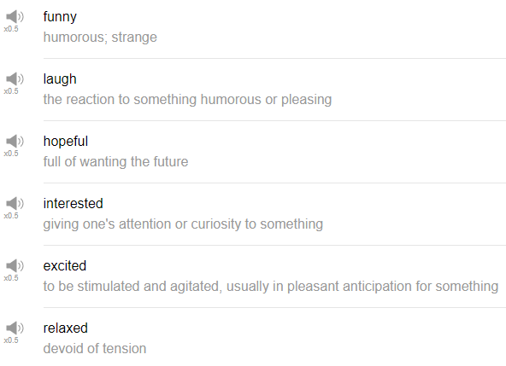

|  |
| --- |
| I'm very happy, yeah! I just... every time... ok. |
| Hi, everybody, my name is Alisha. Welcome back to Top Words! Today we're going to be talking about happy words. Very exciting! so let's go! |
| 1. Happy |
| The first word is happy as you might have guessed happ is a happy word, when you feel good, when you feel positive, when you are excited, you can say I'm happy! I was so happy to see my friend the other day. What makes me happy? Food. I'm happy right now. |
| 2. Energetic |
| When you feel happy, perhaps you also feel energetic, you have that sort of, like, uplifting feeling. This chair is squeaking every time I move up. I don't really describe my friends or people as energetic, i might say a dog or a cat is energetic, like, wow! Your dog is so energetic, what is she doing? She's running everywhere, is she okay? Maybe i would say about myself, I'm very energetic today, if I've had a lot of coffee, like now. |
| 3. Great! |
| You can use this to describe people, a situation, a food, anything that you think is good, is positive, is cool, is groovy, is spectacular, is fantastic, I'm sure we're going to talk about some of these other words later so i should stop saying them. |
| 4. To like |
| Something that you are interested in, something that you think is great, is good, is cool, is awesome. You can like anything, whatever it is, just say "I like..." followed by a noun phrase, that's how you can share your hobbies, the things that make you happy. In a question form, what do you like? What do you like to do? I like eating food, I like cooking food, recently I like tofu. |
| 5. To love |
| You can use it for very close friends, maybe in your language using the word love has a very very strong meaning, but in English we tend to be a little more casual about that. If you say to your, like, your romantic partner, I love you. That is a very deep meaning, you can say it to your friends though, like, so and so, so I love you. That's fine, that's fine, too. We use "love" and "like" to talk about how much we enjoy something. If you say I love watching movies, it sounds like it's maybe one of your favorite activities, it's one of your hobbies, It's something that you really really enjoy. So think about that when you choose like or love. I love cooking, or I love, let's see, trying new beer. |
| 6. Satisfied |
| The next word is satisfied, usually we use the word satisfied after something good has happened to us. So for example, if you go out to a restaurant, and you have a nice meal, you really enjoy the food, afterwards you can say oh I'm satisfied, that was really good. if you've provided a service to somebody, you can say are you satisfied? |
| 7. Proud |
| If you feel very good about an accomplishment, or someone else has accomplished something and they're happy about it, we use the word proud to describe that feeling. So maybe I studied for a few months and I passed a test that was really difficult for me, I feel so proud. Or let's see, my students have been studying for a few years and their conversation skills have improved so much that we can have fun conversations together, I'm really proud of them. Yeah, if you're proud you can say I'm proud. Though be careful if you say I'm so proud, I'm so proud of myself, I'm so proud of myself all the time, you might sound self-centered. |
| 8. Excited |
| The next word is excited, this is usually before you do something that you're very interested in, that you're very happy about, like, I'm going to see a new movie today, I'm so excited. Or I'm going to try a new restaurant, I'm so excited. It's to describe that, maybe, that kind of upward yeah feeling that you have before you do something you're very interested in. I'm excited! You can use this in the past tense too, like, I was so excited to see that movie last week, it was great! What was the last thing I was excited about? Coming here! I'm so excited to cook food today. Oh my god! |
| 9. Funny |
| Something that makes you laugh is funny, I laugh a lot, i think way too many things are funny. This is true, my favorite people are funny people. My friend told me a really funny joke last week. |
| 10. Hope |
| I hope I get to see my friends this weekend. I hope the food that I cook later is going to be delicious. i hope that i can move to a new apartment next year. I hope that my mom has a great birthday next month. Happy birthday, mom, in advance! This might be around your birthday. So hope is a sense that things are going to improve, that things are somehow going to be better than they are now, wanting improvement, believing in improvement in the future is hope. |
| Those are ten happy word I hope that you use them regularly, and in particular the difference between good and "great", and "like" and "love" can really help you to distinguish how much you appreciate something, or maybe help you to explain your feelings more clearly. So thank you very much for watching this episode of Top Words, please subscribe if you have not already, and we will see you again soon, bye! |
| Why am I talking like this? so an important, just a bit a word for the future, the children, the children of the world who... What am i doing? No!!! |